**REAL ESTATE MANAGEMENT SYSTEM**

GROUP MEMBERS:

PRAKHAR ANAND – RA1711003030116

ABHISHEK NISHAD - RA1711003030117

SACHIN SHUKLA - RA1711003030072

RAGHAV KHANNA - RA1711003030069

**CLASS – CSE B**

Abstract

Our Project “Real Estate Management” is related to online application of estate.

Real Estate Management is advanced solution for his/her estate problem.

User shows all the properties of Buyer that are secure & verify & send them to the Builder.

Real Estate but the property & verify them and the online service is provided by us free of charge.

Here registration is also free of cost. So user can registration by using Real System then Buy the property & verify them. After few hours or days our guys put the estate solution.

The Software is so reliable to user. Our main concept is give best & quick result to user.

Introduction

Real Estate management is also the management of personal property, equipment, tooling, and physical capital assets that are acquired and used to build, repair, and maintain end item deliverables. Property management involves the processes, systems, and manpower required to manage the Life Cycleof all acquired property as defined above including acquisition, control, accountability, responsibility, maintenance, utilization, and disposition.

This Project consists of the features of object oriented programming and data file handling.

The Agent can add,delete,modify,display and search the record of the property available.

The Customer can search and see all the existing records.

ROLES

* There are many facets to this profession, including managing the accounts and finances of the real estate properties, and participating in or initiating litigation with tenants, contractors and insurance agencies. Litigation is at times considered a separate function, set aside for trained attorneys. Although a person will be responsible for this in his/her job description, there may be an attorney working under a property manager. Special attention is given to landlord/tenant law and most commonly evictions, non-payment, harassment, reduction of pre-arranged services, and public nuisance are legal subjects that gain the most amount of attention from property managers. Therefore, it is a necessity that a property manager be current with applicable municipal, county, state and Federal Fair Housing laws and practices

**1. Property Maintenance**

Estate maintenance involves the responsibility of keeping the facilities in good condition with regular inspection, troubleshooting, and minor repairs. However, if you own other businesses or you cannot supervise your properties, the upkeep of the facilities can be a stressful task.

Hiring a [property management at Singapore](http://www.estateinfo.sg/) will ensure that your properties get regular servicing from trusted contractors to avoid major repairs that will cost more money. They will also have connections with contractors in Singapore in case the property needs repairs or renovations. The condo manager will make sure that all the repairs and other projects are finished on schedule to avoid interruptions in the daily operations.

**2. Employee Supervision**

The managing agent assigned by the property management office can act as your representative when hiring, training, and supervising your in-house employees. They can perform the background checks and interviews on your behalf to make sure that you will only hire the best workers. You can also delegate the task of handling the salaries and the right to fire an employee. Instead of talking to you directly in case there are any concerns, the employees can speak to the property manager instead and make the reports to you later.

**3. Tenant Management**

Besides making sure that your apartment units have shorter vacancy cycles and finding long-term lease contracts, the tenant condo manager can also check all applicants and manage the existing tenants to make sure there are no problems. The property management team has all the resources and knowledge in handling different customers and the means to screen the applicants for credit records, criminal records, tenancy history, and other related information.

They can also provide a buffer between you and your tenants if they are given the responsibility of enforcing lease agreements and evicting troublesome tenants. The property manager is the authorized point of contact for all your tenants, so that there will always be one person who can deal with complaints, questions about the leases, vacancy notices, emergencies, and evictions.

**4. Leasing Contract**

An estate maintenance agent is not only skilled in customer service but is also an expert in real estate. This means that they will have more resources to help you come up with fair lease contracts that will be attractive to prospective tenants but will also bring in more profits for you. They can also come up with marketing and advertising strategies in case you have vacancies.

Most landlords/landladies fail to take into consideration the fair price of the monthly rent because they do not have the experience and training, but a managing agent can come up with solutions based on the average rates in the area, the trends in real estate, and estimating the value of each unit.

**5. Rental Collection**

One the major responsibilities of estate management is to make sure that the rents are collected on time. However, there will be tenants who will have problems with the rent, a task that some landlords don’t have the ability to deal with fairly. If collecting rent is stressful for you, a managing agent can act as your representative to collect and adjust rents. Not only are they equipped with good communication skills, they are also experts in renting costs and market value to attract more tenants. It will also spare you from having to deal with problematic tenants yourself, so that you can focus on other things.

**6. Financial Reporting**

As the responsible party for rent collection, the property management team will also help you in managing the finances related to your properties. This will ensure that your properties will always have a higher value in the market as well as keep up the maintenance and repair costs. Your condo estate manager can help you compute the deductions for taxes, daily expenses, monthly bills, and the salaries of your in-house employees. The reports will tell you if your business is doing good or if it needs improvement in specific areas.

**7. Additional Paperwork**

Besides managing your tenants, employees, and financial reports, the managing agent is also your go-to expert if there are paperwork and budget reports that need to be completed. If you set a monthly budget for the maintenance and upkeep of your real estate, the property management team must make sure that the money is used honestly and judiciously by keeping records. If there are any areas in property management that you are not familiar with, such as taxes, leasing contracts, and laws related to real estate, the estate manager can help you deal with these problems.

**8. Risk Management**

Estate maintenance means that record-keeping must be meticulous to avoid liabilities. It is a sensitive task because it deals with making money on behalf of a landlord as well as dealing with tenants through an agreed lease contract. The goal is to make the interests of these two parties meet, so that both are happy and satisfied with the relationship. The managing agent must be skilled when it comes to risk management when handling the budget, receipt of payments, management of funds, paying monthly expenses, and even looking for contractors in Singapore to complete projects and repairs.

Reasons for Hiring Property Management Firms

* Property owners hire property management firms for various reasons. Some owners may have many rental properties in their portfolios but lack the time or expertise to maintain the properties and deal with tenants. Some owners only have an interest in owning rental properties and earning profits from them. When this is the case, they hire professional property managers. Absentee landlords also make use of property management services.
* Property owners who participate in affordable housing programs sometimes make use of property management services. This is because participating in such programs requires knowledge of federal guidelines that some owners do not have, even though they wish to reap the benefits of affordable housing programs.

### **Breaking Down Property Management**

In property management, some real estate brokers also operate as property managers. For example, a broker in a resort town may provide buyer and seller agent services, as well as property management services. When this is the case, the real estate broker also lists, shows and leases vacation rentals. Property managers help owners create budgets, advertise rental properties, qualify tenants, collect rent, comply with local landlord-tenant and real estate board laws, and maintain properties. Preventive maintenance, interior and exterior cleaning, and construction all fall within the scope of a property management company's responsibilities. Owners pay property managers a fee or a percentage of the rent generated by a property while under management.

### **Property Management Credentials**

Property management licensing requirements vary among the states. Most states require property management companies to be licensed by the local real estate board. Holding a real estate broker's license allows property managers to list rental properties in the multiple listing service (MLS) and to market the properties by standard real estate marketing methods. Holding a real estate broker's license also allows the property management company to place a real estate board lockbox on a property's door so that other licensed agents can show the property. States such as Delaware, Florida and Illinois require property management companies that provide on-site management services to condominium communities to hold community management licenses.

**Use Case Diagrams**

•A picture

•describes how actors relate to use cases

•and use cases relate to one another

•Diagrams are not essential

•They are helpful in giving an overview, but only secondary in importance to the textual description

•They do not capture the full information of the actual use cases

•In contrast, text ***is*** essential

**Use Case Diagram Objective**

• Built in early stages of development

• Purpose

•Specify the context of a system

•Capture the requirements of a system

•Validate a systems architecture

•Drive implementation and generate test cases

•Developed by analysts and domain experts

**USE CASE DIAGRAM OF ADMIN**

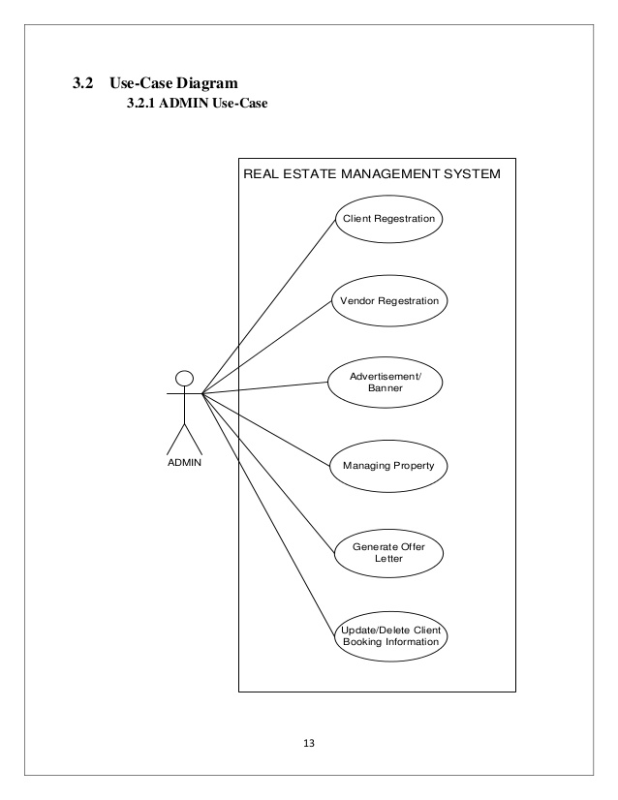

**USE CASE DIAGRAM OF USER**

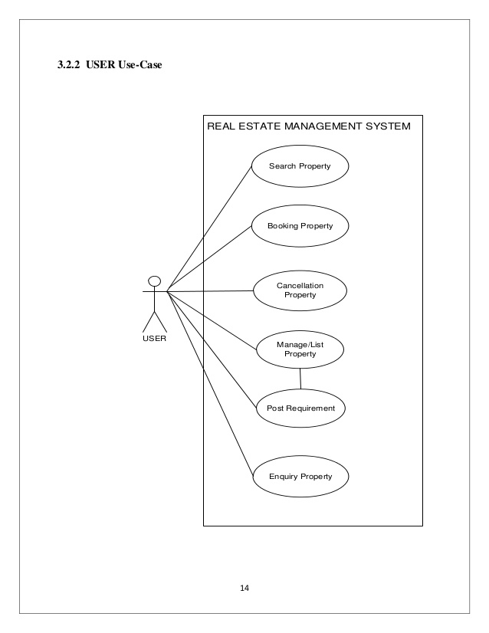

# **Factors That Matter In Real Estate Investment**

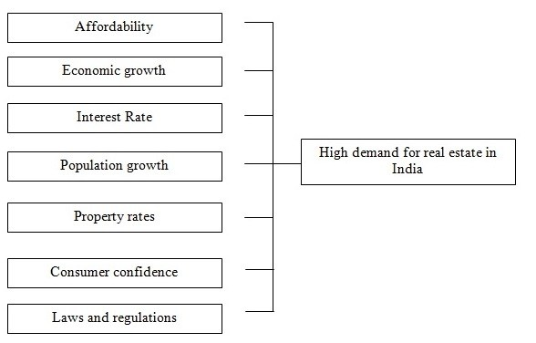

### **Interest Rates**

### 

[Interest rates](https://www.investopedia.com/terms/i/interestrate.asp) also have a major impact on the real estate markets. If you're considering buying a home with a mortgage it is beneficial to research interest rates using a mortgage calculator. Changes in interest rates can greatly influence a person's ability to purchase a residential property. That is because the lower interest rates go, the lower the cost to obtain a [mortgage](https://www.investopedia.com/terms/m/mortgage.asp) to buy a home will be, which creates a higher demand for real estate, which again pushes prices up.

It's important to note that as interest rates rise, the cost to obtain a mortgage increases, thus lowering demand and prices of real estate. However, when looking at the impact of interest rates on an equity investment such as a [real estate investment trust](https://www.investopedia.com/terms/r/reit.asp) (REIT), rather than on residential real estate, the relationship can be thought of as similar to a bond's relationship with interest rates. When interest rates decline, the value of a bond goes up because its [coupon](https://www.investopedia.com/terms/c/coupon.asp) rate becomes more desirable, and when interest rates increase, the value of bonds decrease. Similarly, when the interest rate decreases in the market, REITs' high yields become more attractive and their value goes up. When interest rates increase, the yield on an REIT becomes less attractive and it pushes their value down. (To learn more about these effects, see [How Interest Rates Affect Property Values](https://www.investopedia.com/articles/mortgages-real-estate/08/interest-rates-affect-property-values.asp).)

### **The Economy**

Another key factor that affects the value of real estate is the overall health of the economy. This is generally measured by [economic indicators](https://www.investopedia.com/terms/e/economic_indicator.asp) such as the [GDP](https://www.investopedia.com/terms/g/gdp.asp), employment data, manufacturing activity, the prices of goods, etc. Broadly speaking, when the economy is sluggish, so is real estate.

However, the cyclicality of the economy can have varying effects on different types of real estate. For example, if an REIT has a larger percentage of its investments in hotels, they would typically be more affected by an economic downturn than an REIT that had invested in office buildings. Hotels are a form of property that is very sensitive to economic activity due to the type of [lease](https://www.investopedia.com/terms/l/lease.asp) structure inherent in the business. Renting a hotel room can be thought of as a form of short-term lease that can be easily avoided by hotel customers should the economy be doing poorly. On the other hand, office tenants generally have longer-term leases that can't be changed in the middle of an economic downturn. Thus, although you should be aware of the part of the cycle the economy is in, you should also be cognizant of the real estate property's sensitivity to the [economic cycle](https://www.investopedia.com/terms/e/economic-cycle.asp).

### **Government Policies/Subsidies**

Legislation is also another factor that can have a sizable impact on property demand and prices. [Tax credits](https://www.investopedia.com/terms/t/taxcredit.asp), [deductions](https://www.investopedia.com/terms/t/tax-deduction.asp) and [subsidies](https://www.investopedia.com/terms/s/subsidy.asp) are some of the ways the government can temporarily boost demand for real estate for as long as they are in place. Being aware of current government incentives can help you determine [changes in supply](https://www.investopedia.com/terms/c/change_in_supply.asp) and demand and identify potentially false trends. For example, in 2009, the U.S. government introduced a [first-time homebuyer's tax](https://www.investopedia.com/terms/f/first-time-homebuyer-tax-credit.asp)credit to homeowners in an attempt to jump-start home sales in a [sluggish economy](https://www.investopedia.com/terms/s/sluggisheconomy.asp) (only those who purchased homes between 2008-2010 is eligible). According to the [National Association of Realtors](https://www.investopedia.com/terms/n/national-association-of-realtors.asp) (NAR), this tax incentive alone led to 900,000 homebuyers to buy homes. This was quite a sizable increase, although temporary, and without knowing the increase was a result of the tax incentive, you may have ended up concluding that the demand for housing was going up based on other factors.

### **What's the Best Investment?**

The size and scale of the real estate market make it an attractive and lucrative market for many investors. Investors can invest directly in physical real estate or choose to invest indirectly through managed funds. Investing directly in real estate involves purchasing the residential or [commercial property](https://www.investopedia.com/terms/c/commercial-property.asp) to use as an income-producing property or for resale at a future time. Indirect ways to invest in the real estate market include [investing in real estate](https://www.investopedia.com/articles/pf/06/realestateinvest.asp) investment trusts (REITs), real estate exchange traded funds (ETFs), [commingled real estate funds](https://www.investopedia.com/terms/c/commingledfund.asp) (CREFs) and infrastructure funds. Due to the higher [liquidity](https://www.investopedia.com/terms/l/liquidity.asp) available in the market, the lower [transaction costs](https://www.investopedia.com/terms/t/transactioncosts.asp) and lower [capital requirements](https://www.investopedia.com/terms/c/capitalrequirement.asp), average investors prefer to indirectly invest in real estate. (To learn more about the ways to profit from the housing market, read [Simple Ways To Invest In Real Estate*.*](https://www.investopedia.com/articles/professionaleducation/10/6-steps-becoming-a-real-estate-agent.asp))

### **The Bottom Line**

This article introduced some of the higher-level factors that play a significant role in moving the real estate market, but there are also more complex parts that come in to play. And although some of these aforementioned factors suggest a clear-cut relationship between the factor and the market, in practice, the results can be very different. However, understanding the key factors that drive the real estate market is essential to performing a comprehensive evaluation of a potential investment.

Github Link-<https://github.com/abhisheknishad/Real-Estate-Management>